**SE 102.3 – Web Based Application Development**

**Tutorial**

1. Write HTML codes to create the following tables

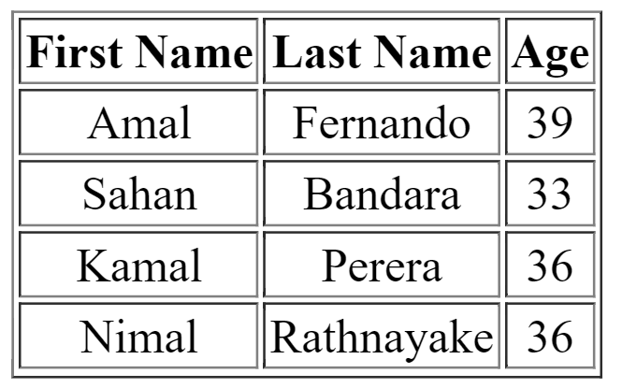

<html>

<head><title>Tutorials </title>

</head>

<body>

<table border=1>

<tr><th>First Name</th>

<th>Last Name</th>

<th>Age</th></tr>

<tr><td>amal</td>

<td>Fernando</td>

<td>39</td></tr>

<tr><td>Sahan</td>

<td>Bandara</td>

<td>33</td></tr>

<tr><td>Kamal</td>

<td>Perera</td>

<td>36</td></tr>

<tr><td>Nimal</td>

<td>Rathnayake</td>

<td>36</td></tr>

</table>

</body> </html>

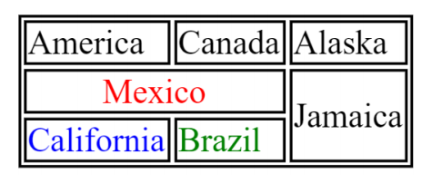

<html>

<head><title>Tutorials </title>

</head>

<body>

<table border=2>

<tr><td>America</td>

<td>caneda</td>

<td>Alaska</td></tr>

<tr><td colspan="2">Mexico</td>

<td rowspan="2">Jamaica</td></tr>

<tr><td>California</td>

<td>Brazil</td></tr>

</table>

</body> </html>

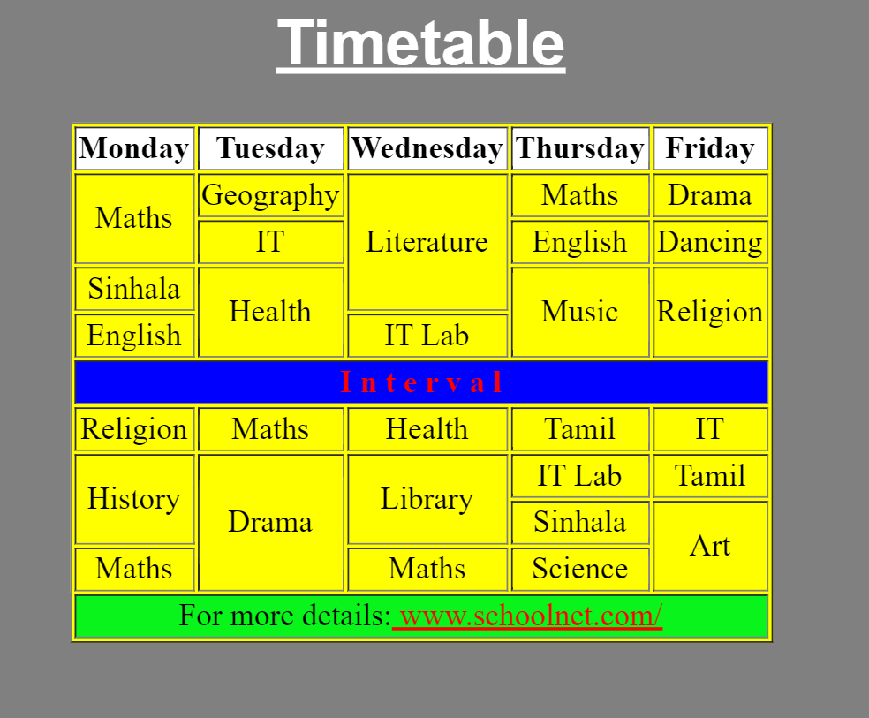

<html>

<head><title>Tutorials </title>

</head>

<body bgcolor="gray">

<table border=30 bgcolor=yellow>

<caption><h1 style= "color:white;"><b><u>Timetable</u></b></h1></caption>

<tr><th>Monday</th>

<th>Tuesday</th>

<th>Wednesday</th>

<th>Thursday</th>

<th>Friday</th>

<tr><td rowspan="2">maths</td>

<td>Geography</td>

<td rowspan="3">Literature</td>

<td>Maths</td>

<td>Drama</td></tr>

<tr><td>IT</td>

<td>English</td>

<td>Dancing</td></tr>

<tr><td>Sinhala</td>

<td rowspan="2">Helth</td>

<td rowspan="2">Music</td>

<td rowspan="2">Religion<td></tr>

<tr><td>English</td>

<td>It Lab</td></tr>

<tr><td colspan="5" bgcolor="blue" font-color="red"><center>Interval</center></td></tr>

<tr><td>Religion</td>

<td>Maths</td>

<td>Health</td>

<td>Tamil</td>

<td>IT</td></tr>

<tr><td rowspan="2">History</td>

<td rowspan="3">Drama</td>

<td rowspan="2"> Library</td>

<td>IT Lab</td>

<td>Tamil</td></tr>

<tr><td>Sinhala</td>

<td rowspan="2">Art</td></tr>

<tr><td>Maths</td>

<td>Maths</td>

<td>Science</td></tr>

<tr><td colspan="5" bgcolor=lightgreen>For more details:<a href="WWW.schoolnet.com/" style="color:red;">WWW.schoolnet.com/</a></td></tr>

</table>

</body> </html>